

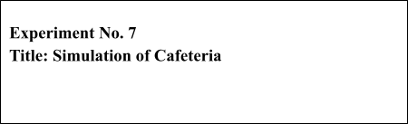



|  |  |  |
| --- | --- | --- |
| **Batch: A3** | **Roll No.:16010421119** | **Experiment No.:7** |

Aim: To Implement the model for Cafeteria using Extend Sim and estimate system performance   
.



**Resources needed:** Extend Sim 10.0.7



**Theory**

**Problem Statement:**

People arrive at a self-service cafeteria at the rate of one every 30 sec (Arrivals are Poisson distributed). 40% got to sandwich counter, where one worker makes a sandwich in approximately 60 sec. The rest go to the main counter; where one server spoons the prepared meal onto a plate in approximately 45 sec. All the customers must pay a single cashier, which takes approximately 25 sec., for all customers eating takes approximately 20 min. After eating 10% of the people go back for dessert, spending an additional 10 min (approx) altogether in the cafeteria. Simulate until 100 people have left the cafeteria, how many people are left in the cafeteria and what are they doing at the time the simulation ends. Except for the arrivals all the other data are exponentially distributed.

Model the problem as a queuing system.

Animate the model in 2D.

Run the simulation till 100 people have departed from the system.

Plot and verify the following results  
● Length of the queue against the number of jobs exited from the system.

● Display how many people are in the system when the simulation ends and what they are doing.

**Concepts:**

**Discrete Event Model**

Simulating a system or process provides a quick and cost effective method for determining the impact, value and cost of change. Simulation models allow for time compression, are not disruptive of the existing system, and are more flexible than real systems. They also provide metrics for meaningful analysis and strategic planning.

Discrete event modelling is an integral part of Six Sigma, business engineering, risk analysis, capacity planning, throughput analysis and reliability engineering projects. The discrete event model is also useful for examining the effect of variations.

**Conceptual Model assumptions:**

The Cafeteria model represents a business operation where customer are given service.

The assumptions for the model are:



• The model runs until 100 customers are exited from the system• Arrival of the customer is Poisson distributed with mean 30.

• All other service times are exponentially distributed with the specified means• The blocks come from the Item, Value, and Plotter libraries



**Procedure / Approach /Algorithm / Activity Diagram:**

*(Write the algorithm for the Autocorrelation test and follow the steps given below)*

**Steps:**

Starting a model and setting simulation parameters

*The following steps are typical when starting any discrete event model.*

✔*Open a new model worksheet*  
✔*Give the command Run > Simulation Setup. In the Setup tab enter the simulation*  *parameters:*   
 *o Global time units: seconds*

✔*If they aren’t already open, open the Item, Plotter, and Value libraries*

✔*Place an Executive block (Item library) on the top left corner of the model worksheet*

✔*Open dialog of the Executive block ; control tab; select options;*

*o Stop Simulation: when count connector value>=;enter 100.*

The Executive block does event scheduling and manages discrete event simulations. It must be present in every discrete event model.

**Start small**

In building any simulation model, start with a simple subset of the process and add detail until you arrive at a completed model that approximates the system that’s being modelled.

The following table lists the blocks that will be added to the worksheet and their use in the model.

Except for the Plotter block from the Plotter library and random number block from value library, the blocks in the table are from the Item library.



**Name (Label)**  **Block Function**

**Create block (**customers) Generates items or values, either randomly or on schedule. If used to generate items, it pushes them into the simulation and should be followed by a queue-type block.

**Purpose in Cafeteria Model**

Generates customers that arrive as per Poisson process



***Set* (Item > Properties)**  Attaches user-assigned properties (attribute, priority, and quantity) to items passing through.

**Purpose in Cafeteria Model**

Set property as preference (sandwich or meal) and further dessert or no dessert

**Queue block**(Entry Line) Acts as a sorted queue or as a resource pool queue. As a sorted queue, holds items in FIFO or LIFO order, or sorts items based on their attribute or priority.

**Purpose in Cafeteria Model**

Holds the customers and, when the server is available, releases one by one in first-in, first-out order.

***Select Item In* (Item > Routing)**  Selects an input and outputs its item.

**Purpose in Cafeteria Model**

For merging the two inputs (customers coming from sandwich counter and meal counter towards) and output one (one cashier).

***Select Item Out* (Item > Routing)** Sends each item it gets to a selected O/P

**Purpose in Cafeteria Model**

Apply the routing rule 40% go to sandwich counter, others go to meal counter and the dessert routing rule 10% have dessert and others don’t have.

**Activity block**Server) Processes one or more items simultaneously. Processing time is a constant or is based on a distribution or an item’s attribute.

**Purpose in cafeteria Model**

Serves the customers as per the service distribution i.e. exponentially distributed

**Random Number block**  Generates the random numbers

**Purpose in cafeteria Model**

Outputs values to a Set block as per the look up table

**Exit** (Exit) Removes items from the simulation and counts them as they leave.



**Purpose in Cafeteria Model**   
Exits the customers from the model.

**Plotter, Discrete Event**   
**Purpose in Cafeteria Model**   
Reports the length of the waiting line and how many jobs has been processed.



✔Starting at the right of the Executive block, place the blocks on the model worksheet in a line from left to right, based on their order in the table.✔Label the blocks as the system entities.

Enter the dialog parameters and settings for each block   
Make the connections   
Run the simulation   
Verify the results   
Animate the model



**Results: (Program printout with output)**

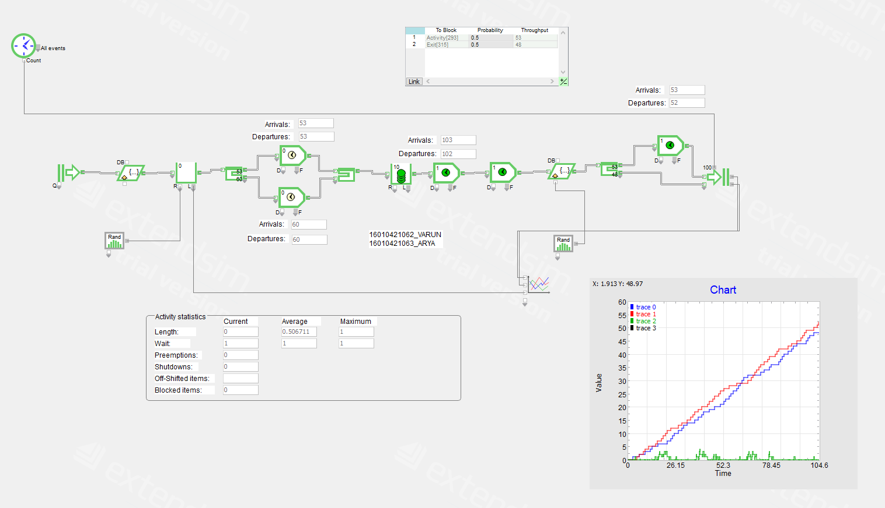

**Program:** *(Printed model developed in Extend Sim)*



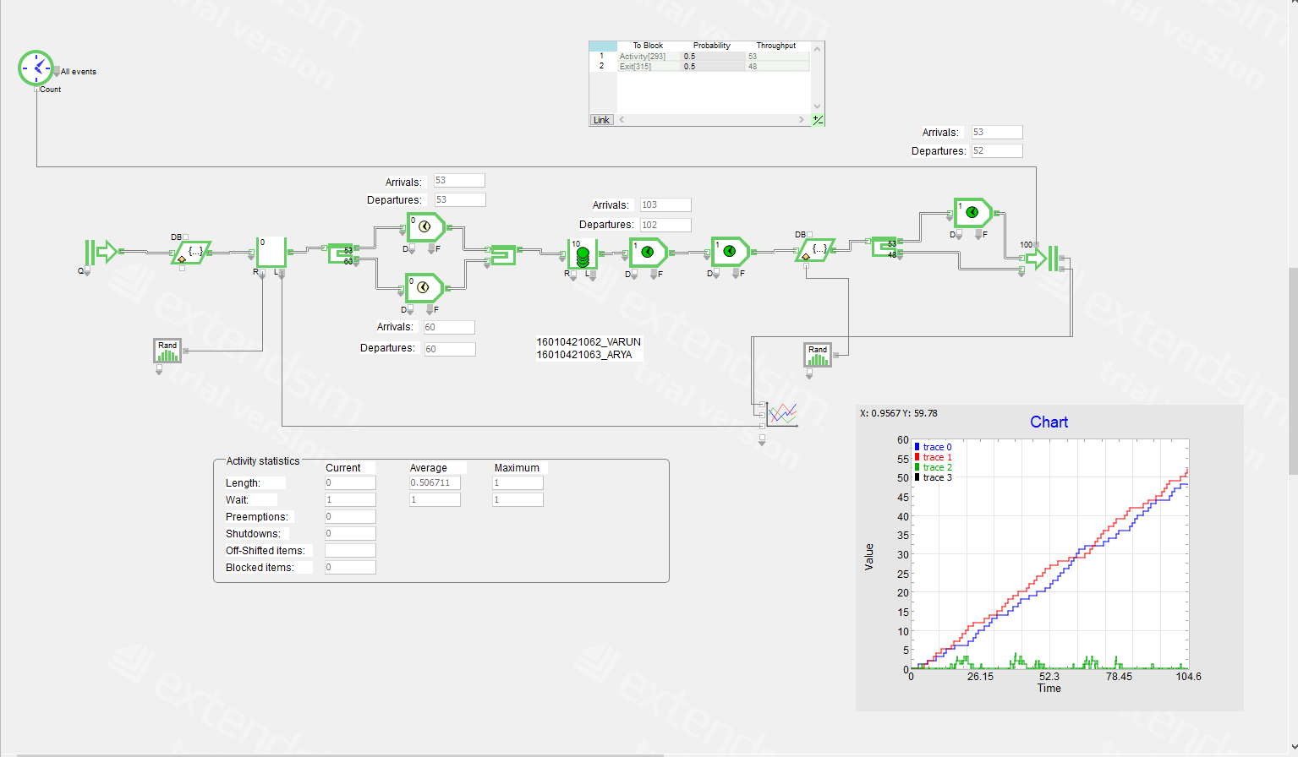

**Output**: *(Printed results i.e. the plotter data)*

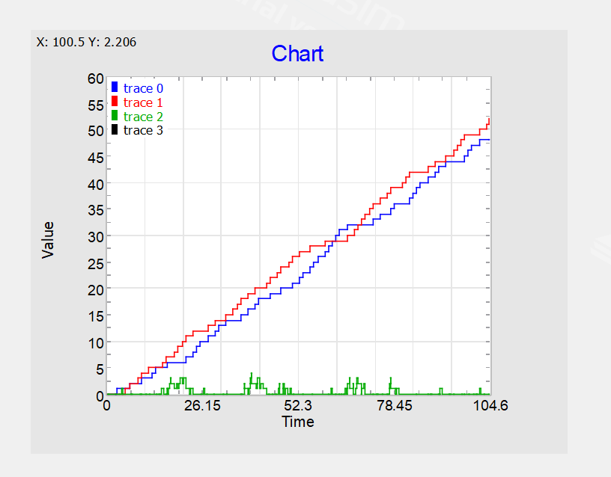



**Questions:**

1. List some features when selecting simulation software.



Ans: When selecting simulation software, consider the following features to ensure the software meets your needs effectively:   
Modeling Capabilities: Look for software that supports the types of models you need to create, whether it's discrete event simulation, system dynamics, agent-based modeling, etc.

User Interface: A user-friendly interface with intuitive tools and menus can greatly enhance productivity and ease of learning.

Simulation Output and Analysis: The software should offer comprehensive tools for visualizing simulation results (charts, graphs, animations) and performing detailed analysis (statistical analysis, optimization).

Customization and Flexibility: Ensure the software allows for customization of models and parameters to fit specific scenarios and needs.

Validation and Verification: Look for software that supports rigorous validation and verification of models to ensure their accuracy and reliability   
Scalability: Depending on your needs, consider whether the software can handle large-scale simulations efficiently.

Integration: Check if the software can integrate with other tools and systems (e.g., databases, programming languages) to facilitate data input and output.

Documentation and Support: Good documentation and responsive technical support are essential for troubleshooting and mastering the software.

Cost and Licensing: Consider the cost structure (one-time purchase, subscription) and licensing terms (e.g., number of users, restrictions on use) to ensure it fits your budget and organizational requirements.

Simulation Libraries and Templates: Pre-built libraries and templates can expedite model development and provide standardized components.

Real-time Simulation: If needed, assess whether the software supports real-time simulation capabilities.

Collaboration: Features for team collaboration and sharing of models can be important if multiple users are working on simulations.

Security: Especially in sensitive applications, ensure the software has adequate security measures to protect intellectual property and data.

Updates and Maintenance: Regular updates and ongoing maintenance from the software provider are important for keeping pace with evolving simulation needs and technologies.

Industry-Specific Features: Depending on your industry (e.g., manufacturing, healthcare, logistics), look for software that offers specialized features tailored to your sector's requirements.

2. Give the physical basis for selecting distribution   
 (i) Poisson   
 (ii) Exponential   
 (iii) Normal   
Ans:   
(i) Poisson Distribution: The Poisson distribution is selected based on the physical basis of modeling events that occur randomly and independently over time or space intervals. It is commonly used to describe the number of occurrences of rare events within a fixed interval, where events happen at a constant average rate but independently of the time since the last event. Examples include the number of arrivals at a service center within a given time period, the number of phone calls received by a call center in an hour, or the number of defects in a manufacturing process.

(ii) Exponential Distribution: The selection of the exponential distribution is grounded in modeling the time between events in a Poisson process. It represents the probability distribution of the time taken between consecutive events occurring at a constant average rate. This distribution is widely used to model phenomena such as the lifespan of certain components, the



time between arrivals of customers at a service point, or the duration until the next occurrence of a radioactive decay.

(iii) Normal Distribution: The normal distribution is chosen based on the physical basis of modeling continuous random variables that are symmetrically distributed around a mean value.

It is characterized by its bell-shaped curve and is applicable to a wide range of natural phenomena where data tend to cluster around a central value with fewer extreme values on either side. Physical measurements such as height, weight, temperature, and test scores often exhibit a normal distribution. The central limit theorem also supports the use of the normal distribution for modeling the sum or average of independent, identically distributed random variables from any distribution, making it a fundamental tool in statistical modeling and analysis.

3. What is the purpose of Output analysis ?

The purpose of output analysis in simulation is to evaluate system performance, verify model accuracy, support decision-making, and facilitate optimization. Through the examination of simulation results such as throughput, resource usage, and waiting times, analysts can assess system behavior and identify areas for improvement. Output analysis helps in comparing scenarios, assessing risks, and guiding continuous improvement efforts by providing actionable insights based on simulation data. It plays a crucial role in communicating findings to   
stakeholders through clear reports and visualizations, ultimately contributing to informed decision-making and system enhancement across various industries.

**Outcomes:**

**CO3 Analyze simulation results to reach an appropriate conclusion.**



**Conclusion: (Conclusion to be based on outcomes)**   
**Understood and implemented the cafeteria problem in extend Sim**

**Grade: AA / AB / BB / BC / CC / CD /DD**

**Signature of faculty in-charge with date**



**References:**

**Books/ Journals/ Websites:**   
**Text Book:**

Banks J., Carson J. S., Nelson B. L., and Nicol D. M., “Discrete Event System Simulation”, 3rd

edition, Pearson Education, 2001.

**Additional Web Resources:**

• Extend sim Users Guide  
• Real Queuing Examples:<http://www2.uwindsor.ca/>hlynka/qreal.html This site contains excerpts from news articlesthat deal with aspects of waiting lines.



• ClearQ:<http://clearq.com/>This company produces “take-a-number” systems for service facilities (e.g., delis), but also provides performance information about the waiting line.

• Qmatic:<http://us.q-matic.com/index.html>Thiscompany produces informational displays and other products to keep customers informed about waiting times.

“Queuing Presentation” by Richard Larson, given at the Institute for Operations•  
Research and the   
Management Science[s:http:](http://caes.mit.edu/people/larson/MontrealINFORMS1/sld001.htm)//[caes.mit.edu/people/larson/MontrealINFORMS1/sld001.htm.](http://caes.mit.edu/people/larson/MontrealINFORMS1/sld001.htm)



• The Queuing Theory   
Tutor:<http://www.dcs.ed.ac.uk/home/jeh/Simjava/queuei>ng/mm1_q/mm1_q.html   
This site has two animated displays of waiting lines. The user can change arrival and service rates to see how performance is affected.

• Myron Hlynka’s Queuing Page[:http:www2.uwindsor.c](http://www2.uwindsor.ca/hlynka/queue.html)a[/hlynka/queue.html](http://www2.uwindsor.ca/hlynka/queue.html)   
This Web site contains information about waiting lines as well as links to other interesting sites.

• Queuing ToolPa[k:ht](http://www.bus.ualberta.ca/aingolfsson/qtp/)tp[://www.bus.ualberta.ca/aingolfsson/qtp/](http://www.bus.ualberta.ca/aingolfsson/qtp/)   
The Queuing ToolPak is an Excel add-in that allows you to easily compute performance measures for a number of different waiting line models

.